**SPL-1 Project Report, 2019**

**MCQ Game**

**Course: Software Project Lab I**

**Course No: SE 305**

Submitted by

***Sadman Sakib***

**BSSE Roll No. : 1005**

**BSSE Session: 2017-2018**

Supervised by

***Professor Dr. Zerina Begum***

**Designation: *Professor* **

**Institute of Information Technology**

**University of Dhaka**

**29-05-2019**

**Table of Contents**

**1. Introduction …..................................................................................................... 1**

**1.1. Background study ............................................................................................. 1-3**

**1.2. Challenges .......................................................................................................... 3**

**2. Project Overview.................................................................................................. 4-7**

**3. User Manual ......................................................................................................... 8-13**

**4. Conclusion ............................................................................................................ 13**

**5. Appendix............................................................................................................... 13**

**6. References ............................................................................................................ 14**

**Index of Figures**

**Figure 1: Implementation of Serialization............................................................ 2**

**Figure 2: Code for Creating Account.................................................................... 4**

**Figure 3: Code for Login Screen………………………………………………… 5**

**Figure 4: Code for serialization …………………........................................................... 6**

**Fig 5: Code for random question……………………………………………………………….……… 7**

Figure 6: User Manual: First screen........................................................................ 8

**Figure 7: User Manual: Input for creating account…………………………… 8**

**Figure 8: User Manual: Input for creating quiz or playing quiz……………………….… 9**

**Figure 9: User Manual: Input for creating quiz ……………………………..... 9**

**Figure 10: User Manual: Input for creating question…………………............. 10**

# Figure 11: User Manual: Input for creating question and adding answer…... 10

**Figure 12: User Manual: Saving Questions…………………………………………………….. 11**

# Figure 13: User Manual: Play quiz screen…………………………………….. 11

# Figure 14: User Manual: Input for answering questions…….…………….. 12

# Figure 15: User Manual : Output for user…………………….………………. 13

**1**

# Introduction

“MCQ Game” is a desktop game which can be used for educational purpose also. It is a game where one can create MCQ questions and at the same time, one can answer those questions and get the number of correct answer and wrong answers.

Here, this game also provide multiple set question sets. That means with same questions , it can change the position of the questions. It can also change the position of the option also.

.

**1.1 Background study**

**MCQ GAME**

**Multiple choice** or **objective response** is a form of an objective assessment in which respondents are asked to select only correct answers from the choices offered as a list. The multiple choice format is most frequently used in educational testing, in market research, and in elections, when a person chooses between multiple candidates, parties, or policies.

Although E. L. Thorndike developed an early scientific approach to testing students, it was his assistant Benjamin D. Wood who developed the multiple choice test. Multiple choice testing increased in popularity in the mid-20th century when scanners and data-processing machines were developed to check the results. Christopher P Sole created the first multiple-choice-Exam for computers on a Sharp Mz 80 computer in 1982. It was developed to aid in Agriculture Engineering, where Latin plant names were difficult to understand and write, and so it was developed to aid people with dyslexia. The first complete exam was developed at St Edwards School in Romsey, Hants.

Multiple choice items consist of a stem and several alternative answers, among which are the correct ("keyed") answer and one or more incorrect ("distractor") answers. The *stem* is the beginning part of the item that presents the item as a problem to be solved, a question asked of the respondent, or an incomplete statement to be completed, as well as any other relevant information. The options are the possible answers that the examinee can choose from, with the correct answer called the *key* and the incorrect answers called *distractors*. Only one answer can be keyed as correct. This contrasts with multiple response items in which more than one answer may be keyed as correct.

Usually, a correct answer earns a set number of points toward the total mark, and an incorrect answer earns nothing. However, tests may also award partial credit for unanswered questions or penalize students for incorrect answers, to discourage guessing. For example, the SAT Subject tests remove a quarter point from the test taker's score for an incorrect answer.

**2**

**Raw File Reading**

For reading data of files, I have to study some functions mentioned below

* Opening file
* Reading and writing
* Closing file

# How to read and write Java object to a file

Java object Serialization is an API provided by Java Library stack as a means to serialize Java objects. Serialization is a process to convert objects into a writable byte stream. Once converted into a byte-stream, these objects can be written to a file. The reverse process of this is called de-serialization.

A Java object is serializable if its class or any of its super-classes implement either the java.io.Serializable interface or its sub-interface, java.io.Externalizable.

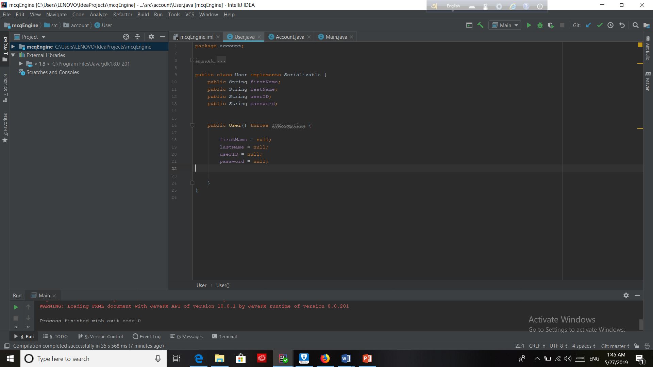

Figure 1: Implementation of Serialization

## 3

## **Writing and Reading objects in Java**

The objects can be converted into byte-stream using java.io.ObjectOutputStream. In order to enable writing of objects into a file using ObjectOutputStream, it is mandatory that the concerned class implements Serializable interface as shown in the class definition below.

Reading objects in Java are similar to writing object using ObjectOutputStreamObjectInputStream. Below example shows the complete cycle of writing objects and reading objects in Java.

On reading objects, the ObjectInputStream directly tries to map all the attributes into the class into which we try to cast the read object. If it is unable to map the respective object exactly then it throws a ClassNotFound exception.

Let us now understand the writing and reading process using an example. We are using the Person class shown above as an object.

# 1.2 Challenges

As it is my first software project, I have to face a lot of challenges. First of all, I cannot understand how to create multiple sets of question from the same question sets. I have to use serialization in this project. Besides, I have to handle large code for the first time.

Some of the challenges are

* Handling large code for the first time
* Learning and understanding serialization
* Designing graphically user interface
* Reading from file
* Creating different question sets
* Changing position of options

**2. Project Overview**

I have divided my whole project into different parts. They are

* + Creating Account
  + Login facility
  + Implementation of serialization
  + Creating player controller
  + Implementation of bangla question facility

# 4

**2.1 Creating Account**

For creating account, it can handle some exceptions, like if any of the account field is empty (first name, last name, password , userid ,it will give an alart . It also throws an exception when we use an userid which has been used earlier.

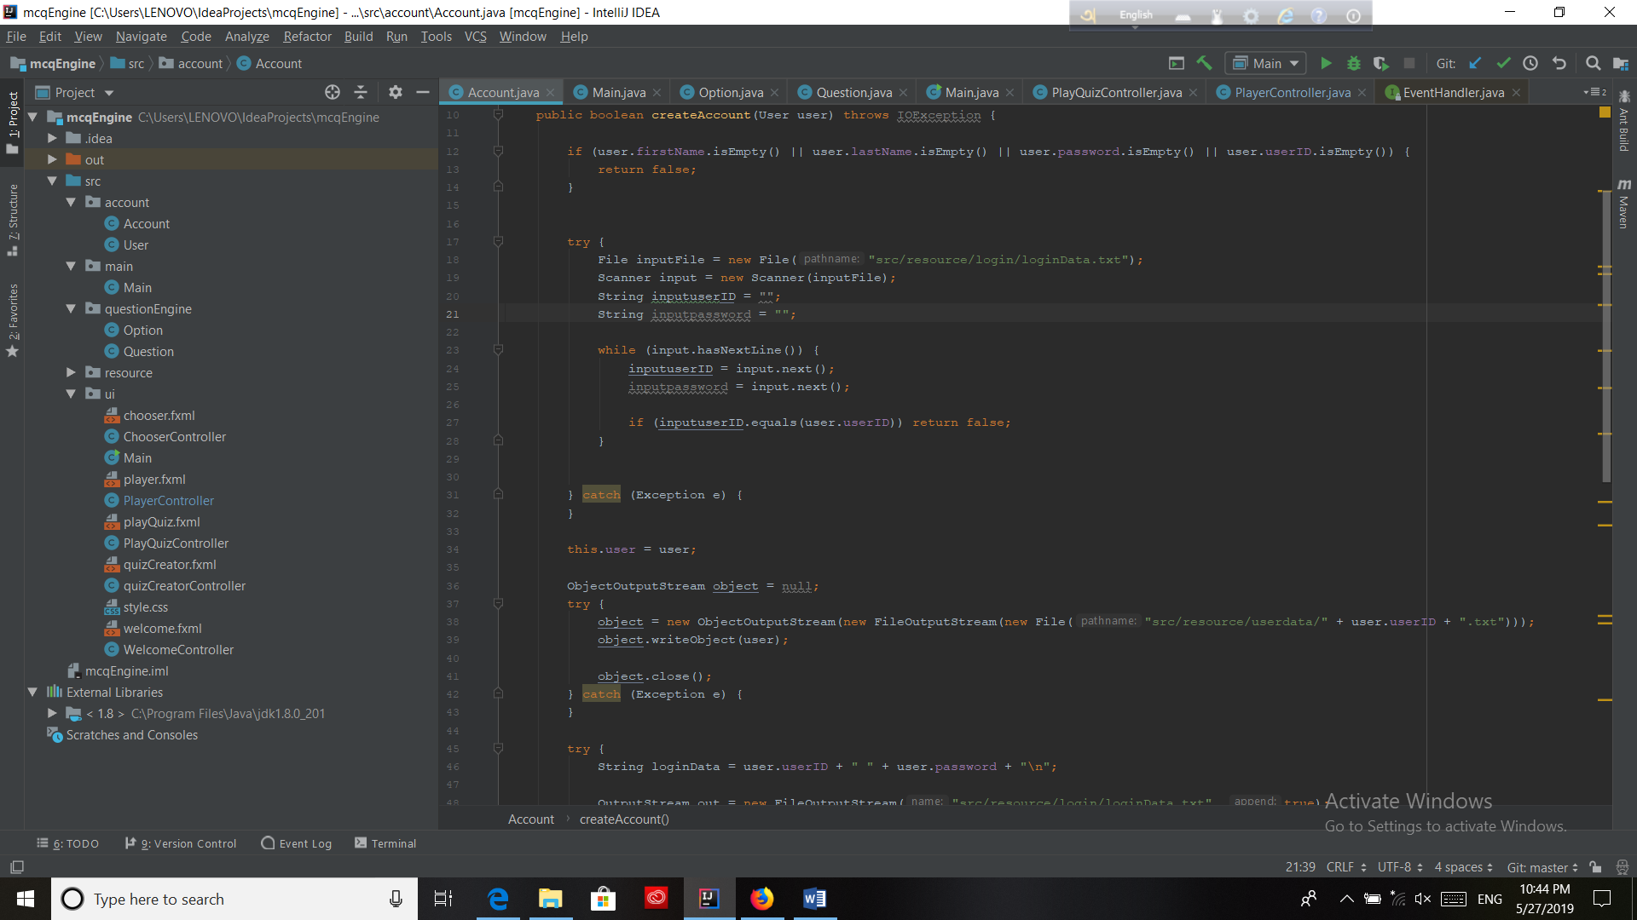

**Figure 2: Code for Creating Account**

**5**

**2.2 Login Facility**

A user can login into his account with his userid and password. The userid and passward are matched with the loginData.txt file which was created earlier.

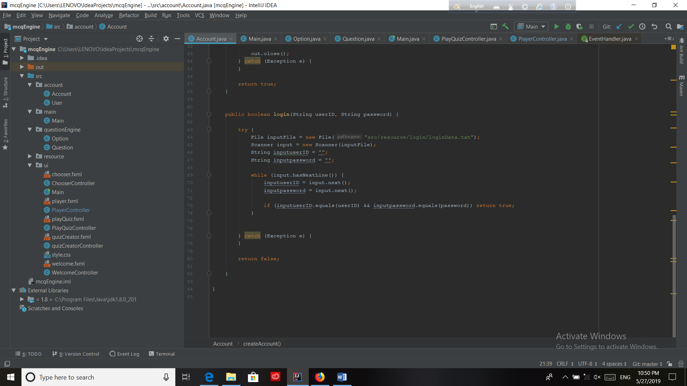

**Figure 3: Code for Login Screen**

**2.3. Implementation of serialization**

For creating a question set for the MCQ game, I have to implement the serializable. I have used it to write the objects in question class.

6

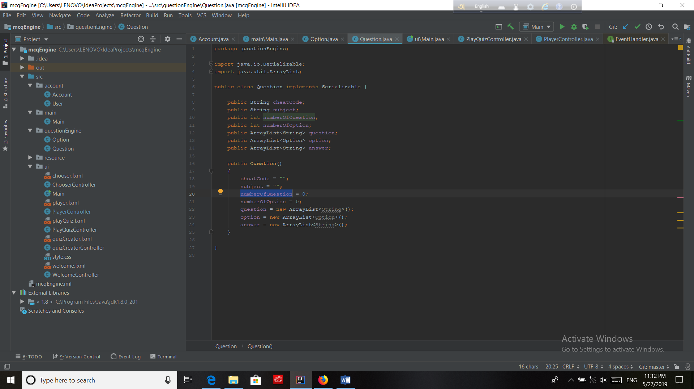

**Figure 4:Code for serialization**

**7**

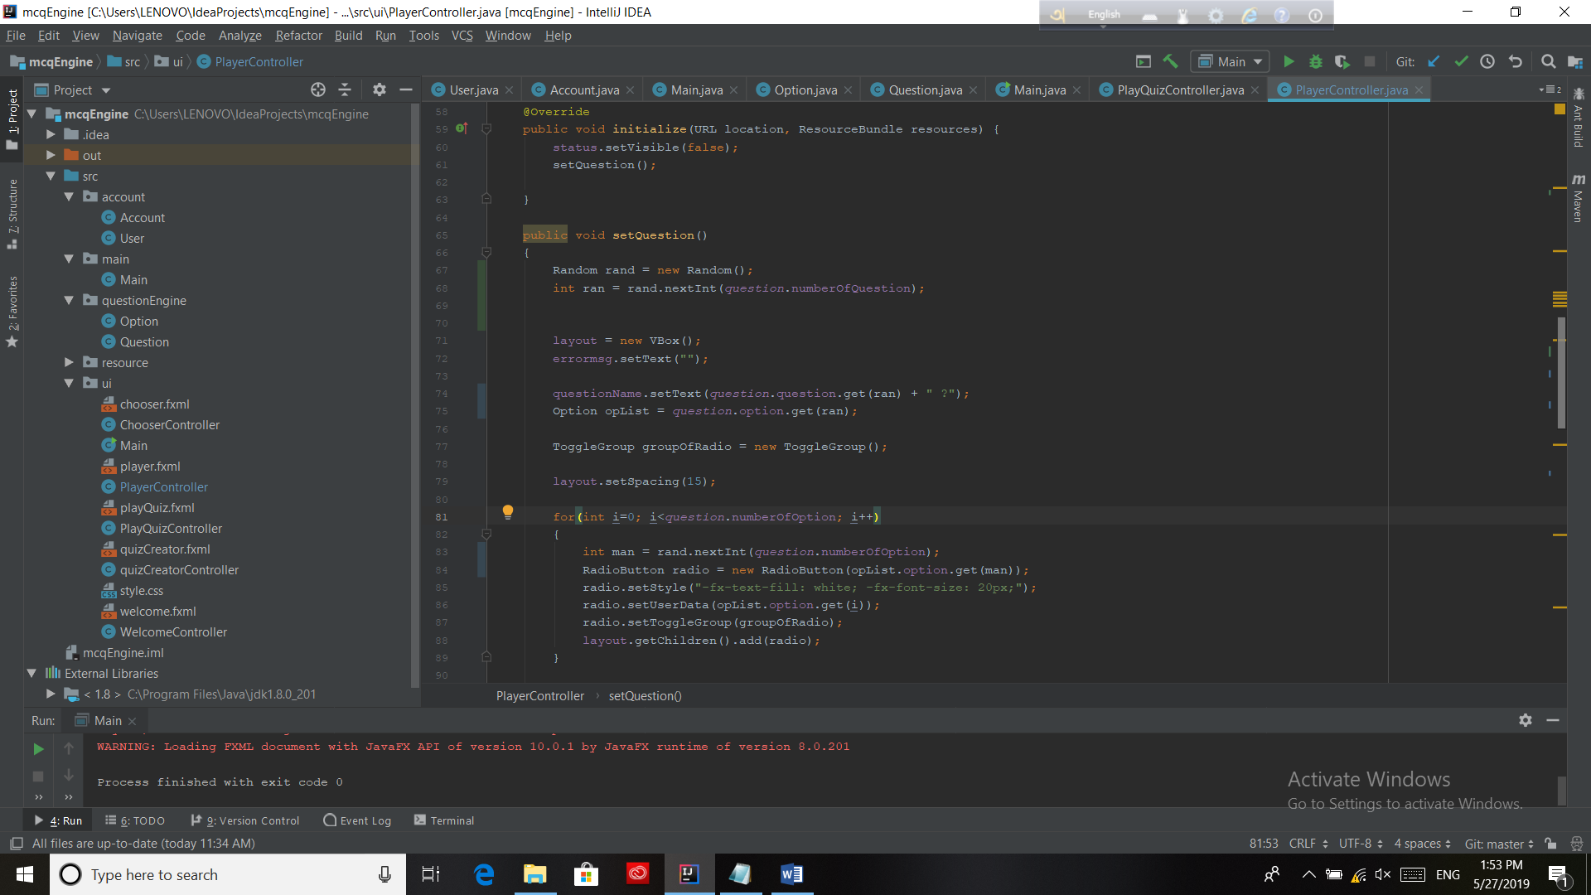

**Fig 5: Code for random question**

# 

**2.4 Implementation of Bangla question facility**

My quiz game can have questions in both Bangla and English. As I used java as coding language , it can take Bangla question as input.

# 

# 

# 8

# 3. User manual

A user can play this game both as a question setter and as a participants. Firstly, the user have to create an account to be a question setter or to be a participants in the game.

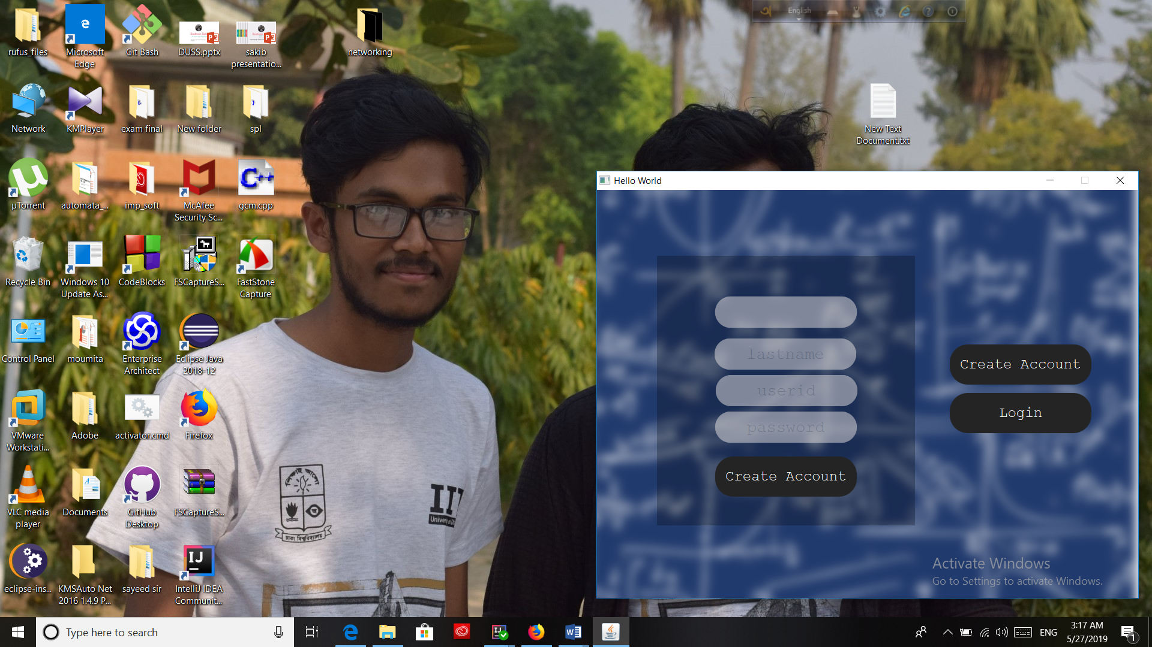

**Figure 6: User Manual: First screen**

For creating an account one have to provide:

* First name
* Last name
* User ID
* Password

An example is given below:

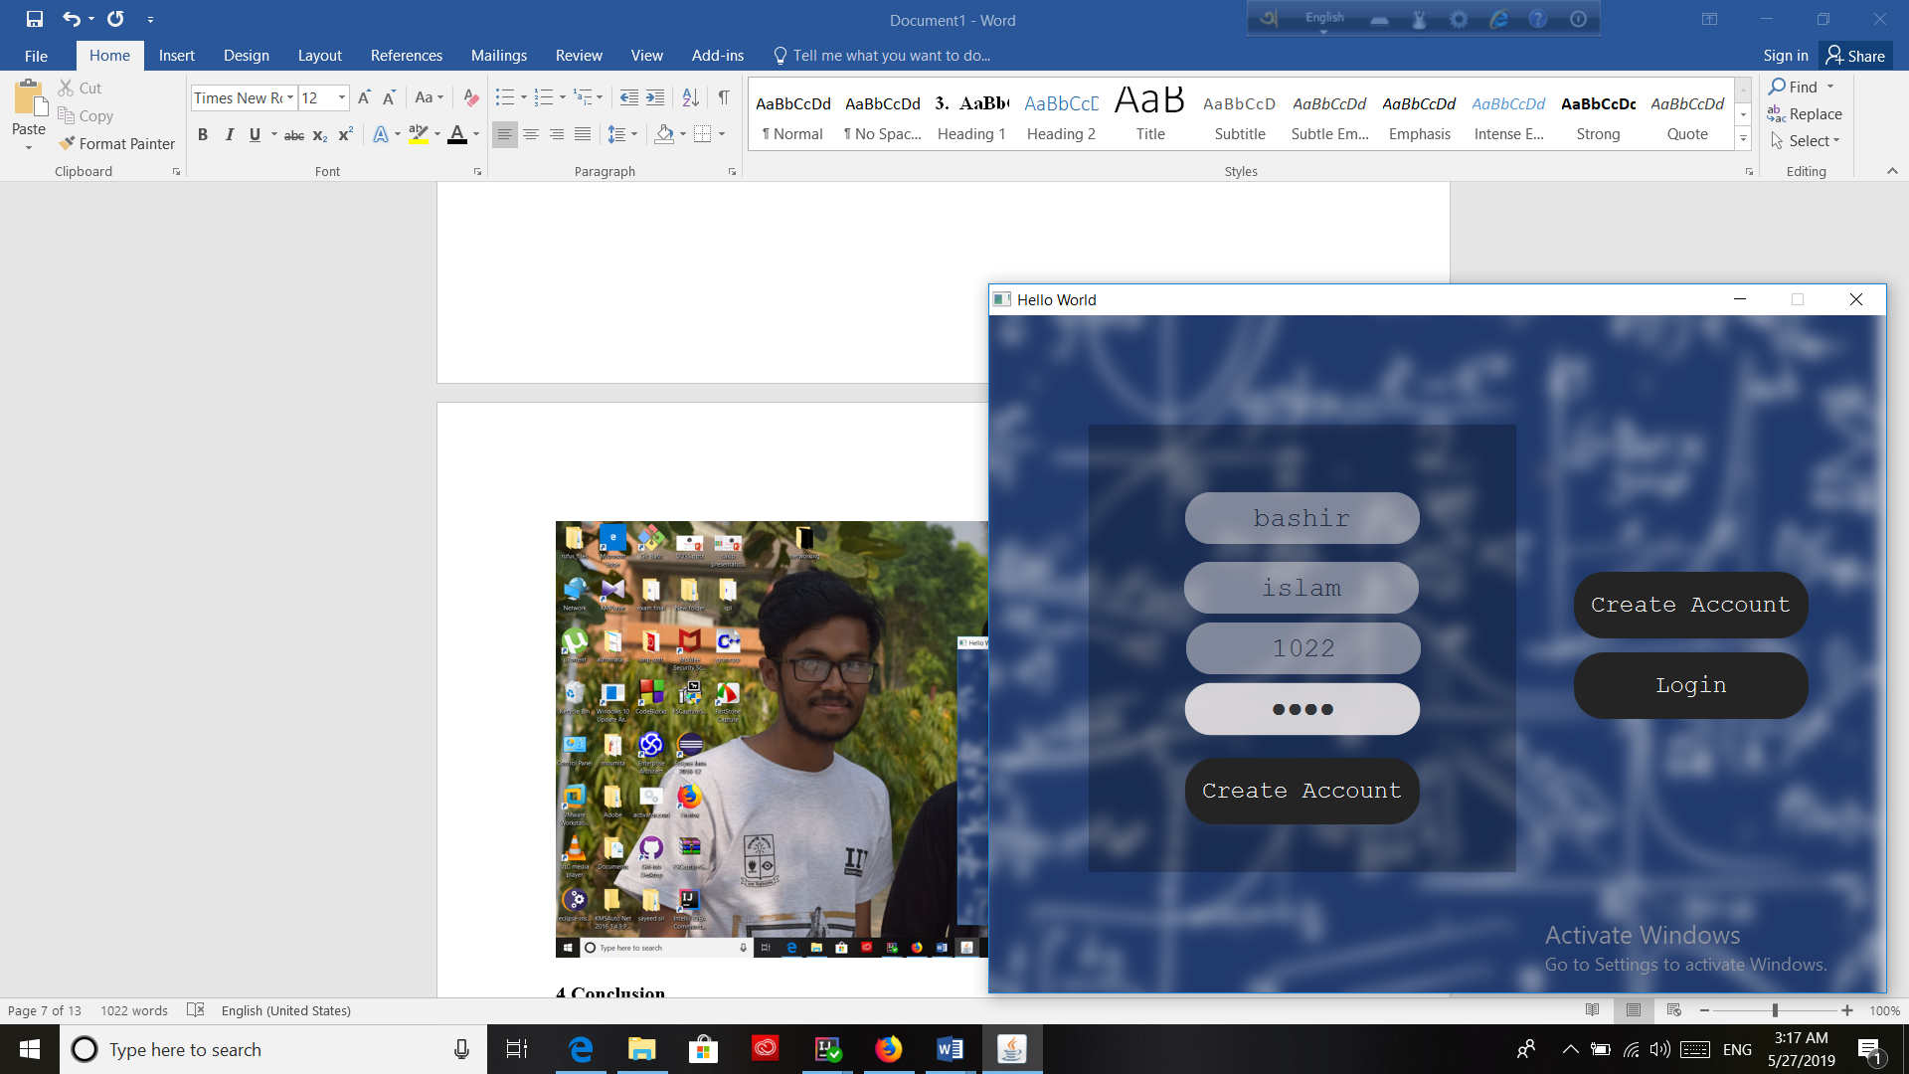

**Figure 7: User Manual: Input for creating account**

# 9

# After creating an account one can login from his account.Then he or she will have an opportunity to play game or create quiz.

# 

# Figure 8: User Manual: Input for creating quiz or playing quiz

# Creating Quizzes:

# For creating a quiz the question setter has to provide:

* A cheat code
* Write the topic name
* Number of questions
* Number of options

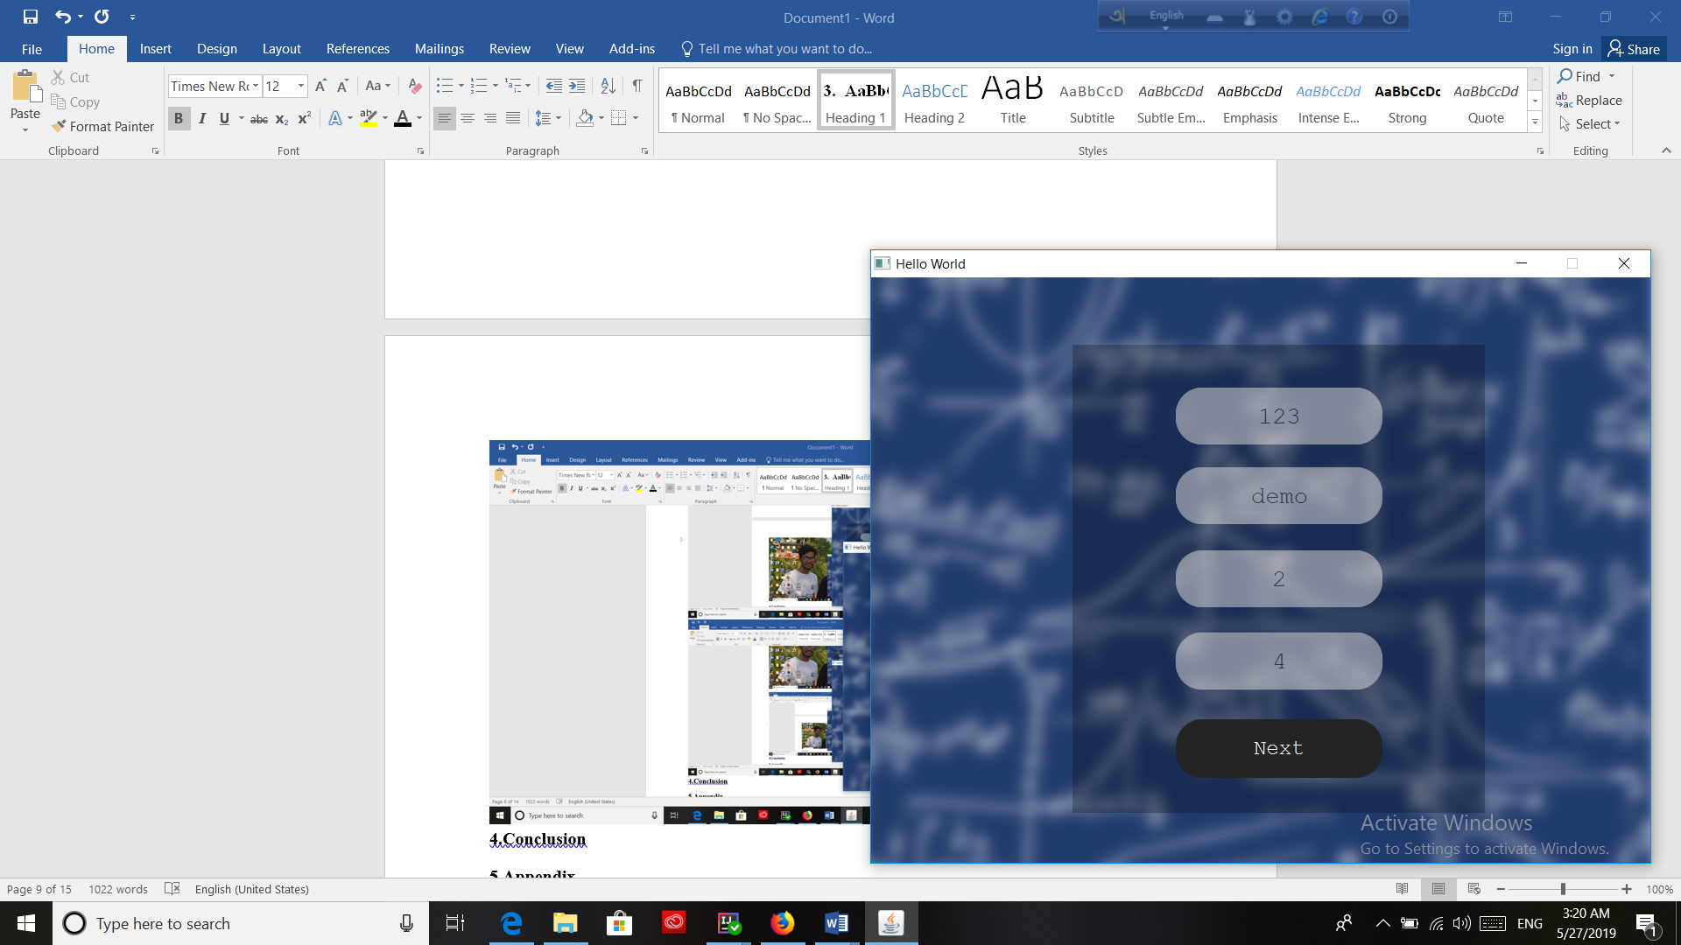

**Figure 9: User Manual: Input for creating quiz**

**10**

After pushing the next button, the user have to provide the questions with options. A user can give any number of options for the questions. The question setter has to include the answer also.

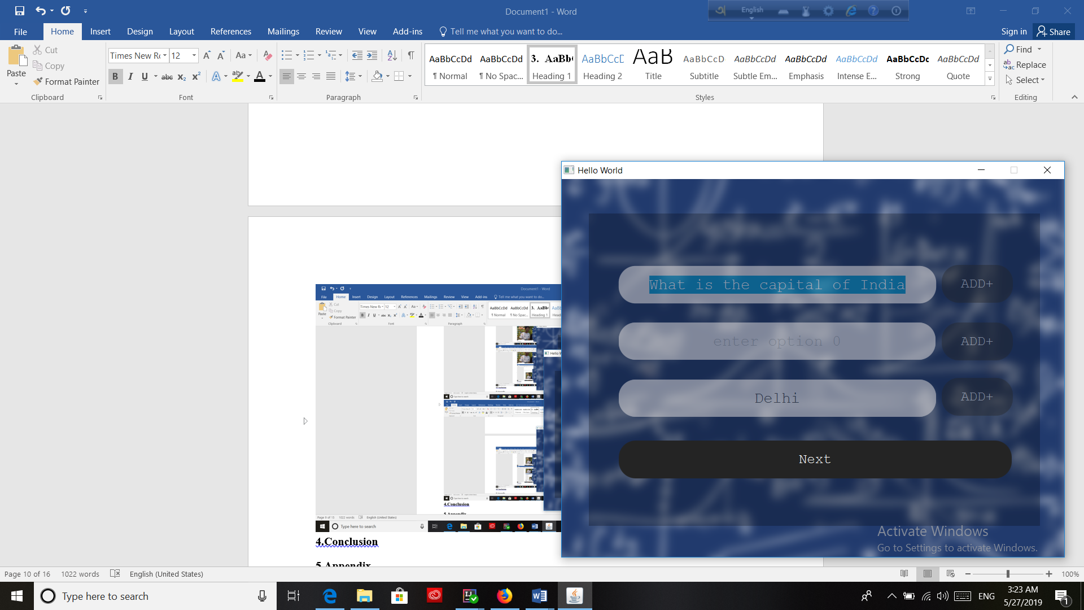

**Figure 10: User Manual: Input for creating question**



**Figure 11: User Manual: Input for creating question and adding answer**

**11**

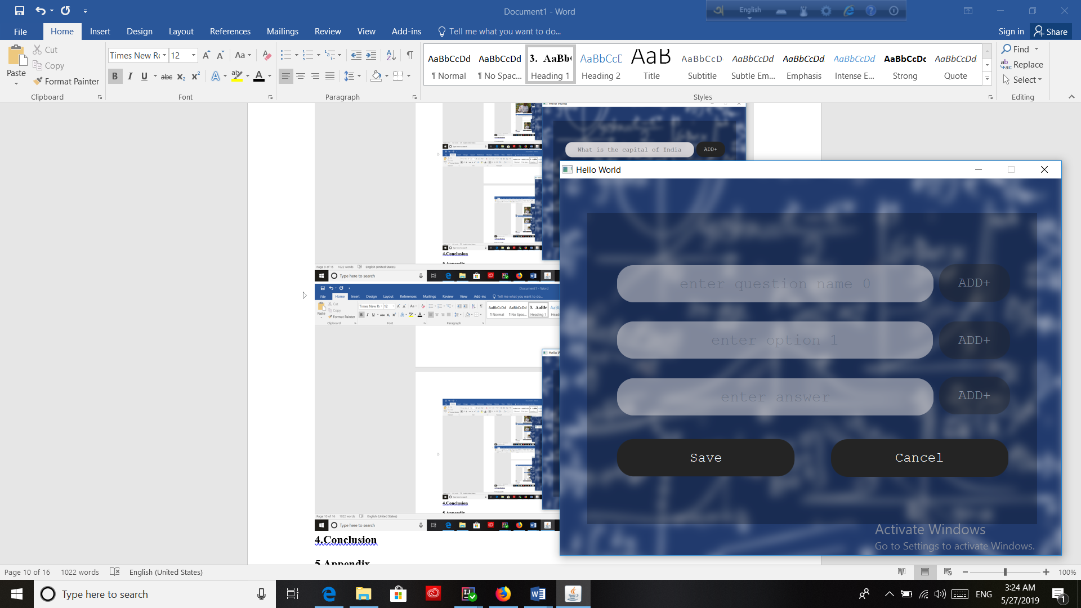

# Figure 12: User Manual: Saving Questions

# The user have to press the save button if he wants to save the questions.

# For playing the MCQ game:

After pressing the “play game” button the following screen will come:

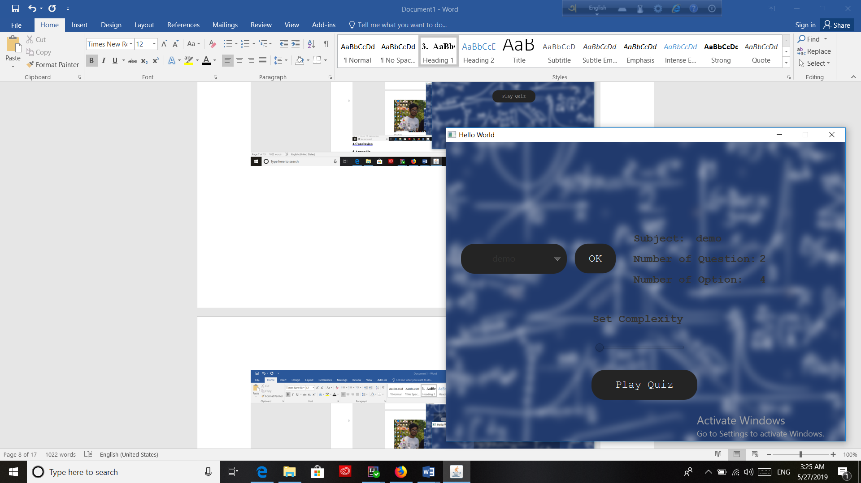

**Figure 13: User Manual: Play quiz screen**

# 12

From the previous screen one can decide on which topic he wants to play the game. Here the user wants to play game on “Demo” topic which has 2 questions with 4 options. The user has to press the play quiz button for playing.

# 

# Figure 14: User Manual: Input for ansering questions

# 13

# 

# Figure 15: User Manual :Output for user

Finally, a score board will show the number of correct answer and the number of wrong answer.

# 4. Conclusion

Implementing serialization helps to understand this new topic and how to read and write file in java. The project also helps me to improve my coding skill and I have learned to handle large code for the first time. I have learnt to use java in different scenario and have learnt to use javafx to create graphical user interface. I hope it will help me to deal with difficulties in future. This project was quiet challenging and I gained a lot of experience from it. I want to thank my supervisor and other respectable teachers for guiding me a lot during this project.

# 5. Appendix

In this project, I have created a MCQ desktop application. For the betterment of this project I will learn android studio and create a mobile apps for MCQ in future. I have created features like a teacher can create MCQ question from this game and create

14

different question sets. So in future, I will add pdf facility which will help the teachers more. A student can play this game and understand his present capability on mathematics.

**6. Reference**

1. <https://en.wikipedia.org/wiki/Multiple_choice/> (Wikipedia, date: 20/ 01/2019)

2. <https://examples.javacodegeeks.com/core-java/io/fileoutputstream/how-to-write-an-object-to-file-in-java/> (java code geeks, date: 24/ 02/2019)

3. <https://www.mkyong.com/java/how-to-read-and-write-java-object-to-a-file/> (mkyong.com, date: 15/03/2019)

4. <https://www.geeksforgeeks.org/generating-random-numbers-in-java/> (geeksforgeeks,

date :03/04/2019)